Real-Time Multi-User Chat Application
“BitChat”


Submitted by:

Abdul-Hadi 2025(s)-SE-5
Muhammad Irfan Shoukat 2025(s)-SE-4
Bilal Shami 2025(s)-SE-23

Submitted to:
Ma’am Ghazala

Department of Computer Science
University of Engineering and Technology Lahore, New Campus

1. Introduction
This document presents the complete design and implementation of a Real-Time Multi-User Chat Application built using Python socket programming. The application runs over a Local Area Network (LAN) and supports simultaneous communication between three or more users. It provides a modern, WhatsApp-style experience including private messaging, group chat rooms, file/image/video sharing, voice and video calls, message forwarding, desktop notifications, and dark mode.
- The system is divided into two files:
server.py which acts as the central message broker, and client.py which combines the full Tkinter GUI and socket networking. Both files use length-prefixed JSON framing for reliable communication over TCP.

2. Project Requirements
The following core features were required and have been implemented:
- Communication between 3+ clients on the same LAN/Wi-Fi
- Real-time message transmission between all active clients
- Display of all active clients in the GUI sidebar
- Sending and receiving of messages, files, images, and videos
- Group chat with room creation, joining, and leaving
- Private one-to-one chat between selected clients
- Voice and video calling feature (OpenCV + PyAudio streaming)
- System notifications (plyer desktop alerts + winsound beeps)
- Message forwarding via right-click context menu

2.1. Objectives
- To develop a multi-user chat system
- To enable real-time communication between users
- To implement group chat and private chat features
- To allow file, image, and video sharing
- To design a user-friendly graphical interface

2.2. Technologies Used
- Python
- Socket Programming
- Threading
- Tkinter / PyQt (for GUI)
- JSON
- BASE 64
- OS
- IO
- STRUCT
- TIME
- DATETIME
- TYPING
- PILLO
- PYAUDIO
- CV-2
- PLATFORM
- WINSOUND

4. System Design and Architecture

4.1 Architecture Overview
The application follows a classic Client-Server architecture using TCP/IP sockets. The server acts as a central message broker — it accepts connections from multiple clients, maintains a registry of active users and chat rooms, and routes messages between them. Each client runs an independent GUI application that connects to the server on startup.

4.2 Module and Class Breakdown
Function Name | File Name | Responsibility
__init__ | Chat_server.py | Initializes server socket, data structures (clients, groups, calls), lock, and data directory.
_setup_data_directory | Chat_server.py | Creates and selects a directory to store server files and data.
start | Chat_server.py | Starts the server, binds socket, listens for incoming connections, and spawns client threads.
send_msg | Chat_server.py | Sends JSON data to clients using length-prefixed message framing.
recv_msg | Chat_server.py | Receives and decodes incoming JSON messages from clients.
handle_client | Chat_server.py | Manages client registration, communication loop, and disconnection handling.
process | Chat_server.py | Routes incoming messages to the correct handler function.
_message_payload | Chat_server.py | Builds a standard message format (sender, content, timestamp, etc.).
_handle_private_message | Chat_server.py | Sends private messages between two users.
_handle_group_message | Chat_server.py | Sends messages to all members of a group.
_handle_create_group | Chat_server.py | Creates a new chat group and assigns the owner.
_handle_join_group | Chat_server.py | Adds a user to an existing group.
_handle_leave_group | Chat_server.py | Removes a user from a group and deletes it if empty.
_handle_delete_group | Chat_server.py | Deletes a group if requested by the owner.
_handle_typing | Chat_server.py | Sends typing status notifications to users or group members.
_handle_start_call | Chat_server.py | Initiates a voice or video call between users.
_handle_call_response | Chat_server.py | Handles acceptance or rejection of a call.
_handle_end_call | Chat_server.py | Ends an ongoing call and notifies the other participant.
_handle_call_media | Chat_server.py | Relays audio/video data between users during a call.
_handle_forward_message | Chat_server.py | Forwards messages to another user or group.
broadcast_users | Chat_server.py | Sends updated list of online users to all connected clients.
send_groups | Chat_server.py | Sends list of groups to a specific client.
broadcast_groups | Chat_server.py | Sends updated group list to all connected clients.

__init__ | Chat_client.py | Initializes client variables, UI settings, call state, and starts GUI setup.
setup_gui | Chat_client.py | Creates main application window and initializes layout.
show_login | Chat_client.py | Displays login screen for server IP and username input.
connect | Chat_client.py | Starts connection process to server using a thread
_connect_thread | Chat_client.py | Establishes socket connection and handles registration with server
on_connected | Chat_client.py | Switches from login screen to main UI after successful connection.
on_error | Chat_client.py | Displays connection errors and resets connection state.
send_msg | Chat_client.py | Sends JSON message to server using length-prefixed framing.
recv_msg | Chat_client.py | Receives and decodes messages from server
_chat_key | Chat_client.py | Generates a unique key for private chat between two users.
_store_message | Chat_client.py | Stores messages in local memory for chats/groups.
receive_loop | Chat_client.py | Continuously listens for incoming messages from server.
handle_message | Chat_client.py | Routes received messages to appropriate handler functions.
_handle_user_list | Chat_client.py | Updates list of online users
_handle_group_list | Chat_client.py | Updates list of groups.
handle_private_msg | Chat_client.py | Processes incoming private messages.
handle_group_msg | Chat_client.py | Processes incoming group messages.
handle_msg_sent | Chat_client.py | Handles confirmation of sent messages.
handle_typing | Chat_client.py | Displays typing indicators for users/groups.
clear_typing | Chat_client.py | Clears typing indicator after timeout.
show_notification | Chat_client.py | Displays notifications (placeholder function)
create_main_ui | Chat_client.py | Builds main chat interface with sidebar and chat panel.
on_mousewheel | Chat_client.py | Handles scrolling in chat/user list.
on_search_focus | Chat_client.py | Handles search bar focus behavior.
switch_tab | Chat_client.py | Switches between chats and groups tab.
refresh_list | Chat_client.py | Updates displayed list of users/groups.
create_list_item | Chat_client.py | Creates UI element for user/group in sidebar.
on_item_hover | Chat_client.py | Handles hover effects for list items.
show_welcome | Chat_client.py | Displays welcome screen when no chat is selected.
open_chat | Chat_client.py | Opens selected chat and builds chat UI.
load_messages | Chat_client.py | Loads stored messages into chat window.
display_message | Chat_client.py | Displays a message bubble in the chat UI
scroll_to_bottom | Chat_client.py | Scrolls chat view to latest message.
on_typing | Chat_client.py | Sends typing status to server.
send_text | Chat_client.py | Sends text message to user or group.
send_file | Chat_client.py | Sends file (image/video/document) to chat.
save_file | Chat_client.py | Saves received file to local system.
show_context_menu | Chat_client.py | Displays right-click menu for messages.
forward_message | Chat_client.py | Forwards message to another user/group.
copy_message | Chat_client.py | Copies message text to clipboard
create_group | Chat_client.py | Sends request to create a new group.
join_group | Chat_client.py | Sends request to join a group.
leave_current_group | Chat_client.py | Leaves the currently selected group.
toggle_theme | Chat_client.py | Switches between dark and light themes.
start_call | Chat_client.py | Initiates voice or video call.
handle_incoming_call | Chat_client.py | Handles incoming call request.
show_call_dialog | Chat_client.py | Displays call window UI.
_calculate_video_sizes_for_screen | Chat_client.py | Calculates video sizes for display.
_build_call_footer | Chat_client.py | Builds call UI footer (buttons, status).
_create_call_action_button | Chat_client.py | Creates styled buttons for call actions.
_build_video_panels | Chat_client.py | Creates UI panels for video display.
accept_call | Chat_client.py | Accepts incoming call.
reject_call | Chat_client.py | Rejects incoming call.
handle_call_accepted | Chat_client.py | Handles call accepted event.
handle_call_connected | Chat_client.py | Updates UI when call is connected.
handle_call_rejected | Chat_client.py | Handles call rejection.
handle_call_ended | Chat_client.py | Handles call termination.
handle_call_media | Chat_client.py | Processes audio/video data from server.
start_media_streams | Chat_client.py | Starts audio/video streaming.
audio_capture_loop | Chat_client.py | Captures and sends audio data.
video_capture_loop | Chat_client.py | Captures and sends video frames.
cleanup_audio | Chat_client.py | Stops and cleans up audio resources.
cleanup_video | Chat_client.py | Stops and releases video resources.
stop_media_streams | Chat_client.py | Stops all media streams.
start_call_timer | Chat_client.py | Starts call duration timer.
update_call_timer | Chat_client.py | Updates call timer display.
end_call | Chat_client.py | Ends active call.
close_call_dialog | Chat_client.py | Closes call window and resets state.
run | Chat_client.py | Starts the Tkinter main loop.`

4.3 Communication Protocol
All packets are JSON dictionaries transmitted with 4-byte length headers. Every packet contains a 'type' field plus type-specific fields:
- register — client sends username on connect
- register_ok — server confirms with full user+room lists
- private_msg — DM: sender, target, text, time
- group_msg — room message: sender, room, text, time
- file_transfer — sender, filename, data (base64), filetype, target/room
- create_room / join_room / leave_room — room management
- room_joined — server sends last 50 history messages
- call_request / call_response / call_end — call signalling with peer IP
- forward_msg — forwarder, original_sender, original_text
- user_list / room_list — broadcast after every join/leave/disconnect
- system — server-generated announcements

4.4 Threading Model
Server side: one daemon thread is spawned per connected client (_handle_client). Shared data structures (clients dict, rooms dict, history dict) are protected by a single threading.Lock() to prevent race conditions.
Client side: one background daemon thread (receive_thread) continuously reads incoming packets. All GUI updates are safely dispatched to the main Tkinter event loop using root.after(0, callback), ensuring thread safety.

5. GUI Implementation

5.1 Login — Username Dialog
When the application starts, a simpledialog.askstring popup requests the username. The client then sends a 'register' packet to the server. On success (register_ok), the sidebar is populated with the current user and room lists.

5.2 Main Window Layout
The window is a Paned Window split into two halves:
- Left Sidebar (240px) — Two list boxes: Contacts (DMs) and Rooms (Groups). Each has a real-time search/filter Entry above it. Room control buttons (Join, Create, Leave) sit below the rooms list. Unread message counts appear as badges next to names.
- Right Chat Area — A header bar shows the active channel name and houses the Voice (, Video , and Hang Up buttons. Below is a Scrolled Text message display. The input bar has a file attachment button , a text entry field, and a Send button. A status bar at the bottom shows connection state.

5.3 Dark Mode
A theme toggle button (☀️/🌙) switches the entire UI between light (#e9ecef background, black text) and dark (#2b2b2b background, white text) modes. All major frames, the message area, labels, and the status bar update their colors.

5.4 Unread Count Badges
When a message arrives in a channel that is not currently open, the unread counter increments and the listbox entry is updated to show e.g. 'Alice (3)'. Switching to that channel resets the count to zero.

6. Features Implementation
Feature | Description | Status
Multi-Client TCP | 3+ clients on same LAN simultaneously | ✅
Length-Prefixed Framing | struct.pack 4-byte header — reliable large data | ✅
Private DM Chat | One-to-one encrypted channel key | ✅
Group Rooms | Create / Join / Leave with history replay | ✅
File Transfer | Base64 chunked — images, videos, files | ✅
Voice Call | PyAudio UDP stream + OpenCV video | ✅
Video Call | cv2 frame capture → base64 → UDP stream | ✅
Message Forwarding | Right-click → Forward to user or room | ✅
System Notifications | plyer desktop alerts + winsound beep | ✅
Pop-up Alerts | Tkinter messagebox for incoming calls | ✅
Chat History | Last 50 msgs replayed on room join | ✅
Dark Mode | Full theme toggle (dark/light) | ✅
Search/Filter | Real-time filter for users and rooms | ✅
Unread Count | Badge count shown in sidebar lists | ✅
Threading | 1 daemon thread per client (server side) | ✅
Disconnect Cleanup | Users removed from all rooms on exit | ✅

6.1 Private Chat (DM)
Selecting a username in the Contacts listbox switches the chat area to that DM channel. Text messages are sent as private_msg packets. The server generates a canonical key (dm: + sorted([u1,u2])) to store the shared history. Both sender and receiver see the message immediately (server echoes back to sender).

6.2 Group Chat Rooms
Creating a room sends create_room; the server adds the creator as the first member and broadcasts the updated room list to everyone. Joining sends join_room; the server replies with room_joined including the last 50 historical messages so late joiners see context. Leaving sends leave_room; if the room becomes empty it is automatically deleted.

6.3 File / Image / Video Transfer
Clicking the 📎 button opens a file picker. The file is read in binary, base64-encoded, and sent as a file_transfer packet with a filetype field ('image', 'video', or 'file'). The server routes it to the target user or all room members. The receiver decodes and saves the file to ~/Downloads/ChatApp_Files/. Images are rendered inline in the chat area using PIL.ImageTk.

6.4 Voice and Video Calling
Clicking 📞 or 🎥 sends a call_request packet to the selected DM contact. The server forwards it with the caller's IP address (extracted from the socket). The recipient sees a Tkinter messagebox asking to accept or reject. On acceptance, the call_response is routed back, and both sides begin UDP streaming — PyAudio for audio frames and OpenCV for video frames. A Hang Up button stops all streams and sends call_end.

6.5 Message Forwarding
Right-clicking any text in the message area shows a context menu with 'Forward Message'. The user selects the text to forward, enters the target (username or room) in a dialog, and the client sends a forward_msg packet. The server routes it and the recipient sees it labeled with both the forwarder's name and the original sender's name.

6.6 Notifications and Sounds
When a message arrives in a non-active channel, the system attempts to show a desktop notification using the plyer library (cross-platform). On Windows, a winsound.Beep is played as an audio alert. For incoming calls, a louder and longer beep signals urgency. All of this runs in the background without blocking the GUI.

Source Code OUTPUT:-

Chat _server.py — Complete Server
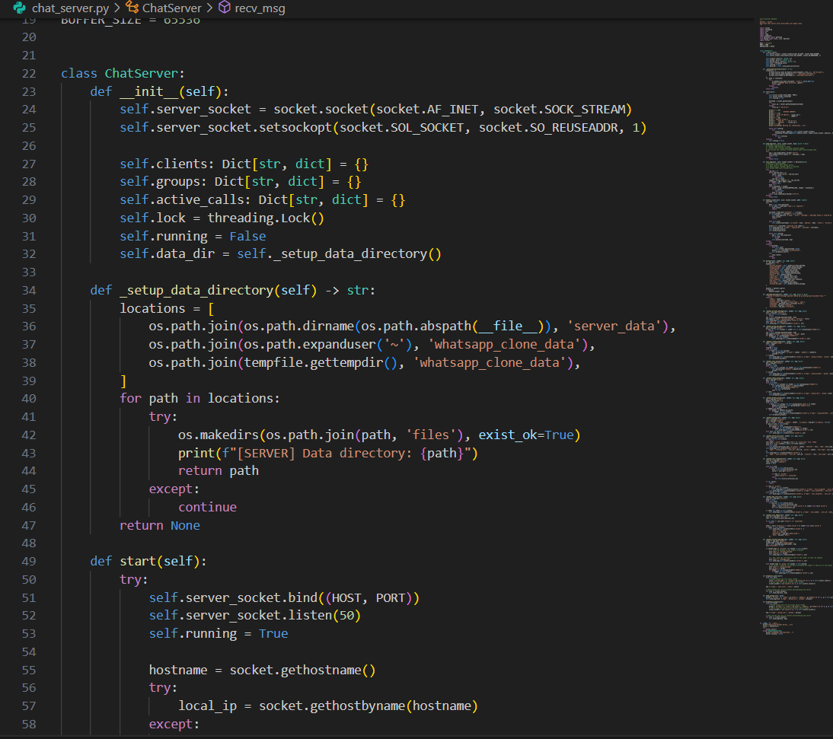

Chat_ client.py — Complete Client GUI
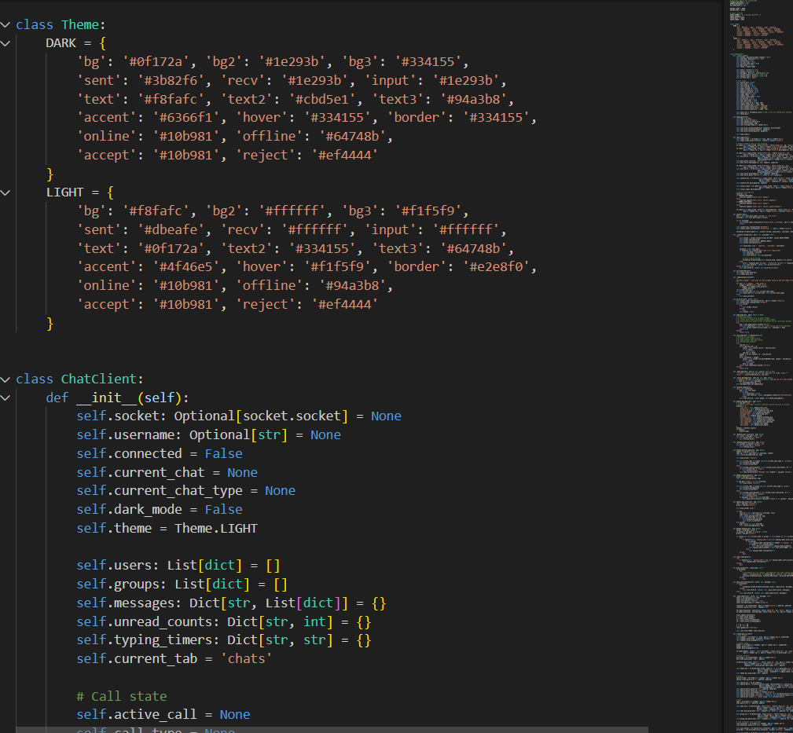

OUTPUT IMAGES
Image 1:- login
This is the login screen. When the app starts, a dialog box appears asking the user to enter their username and ip address to connect to the server.
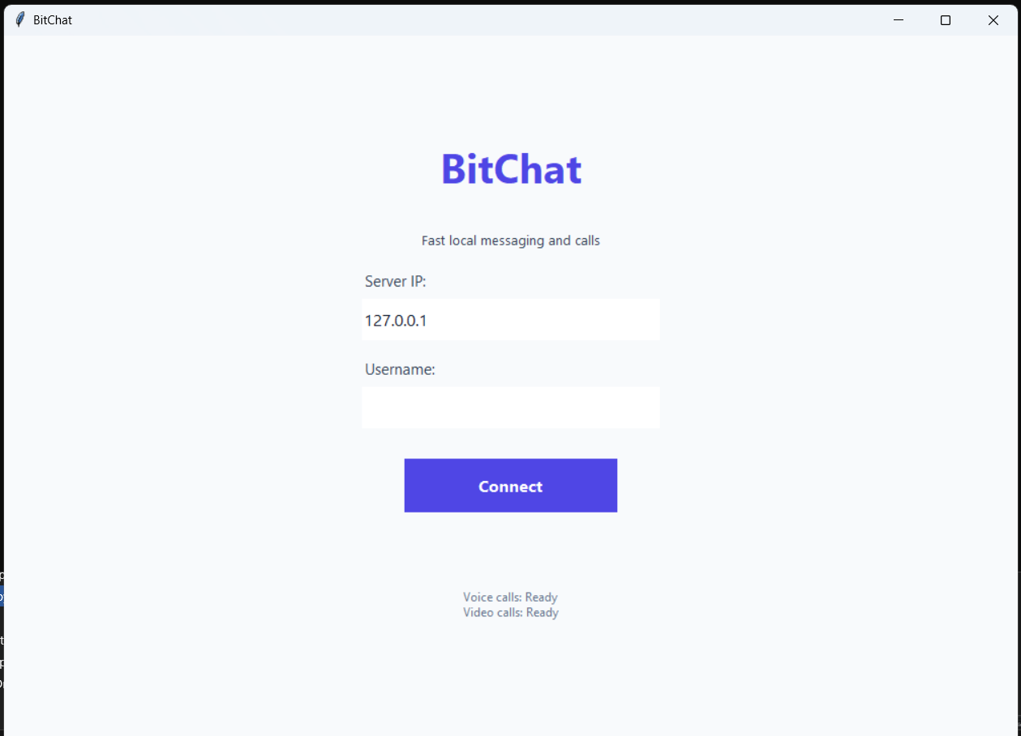
Image 2:- Group creation
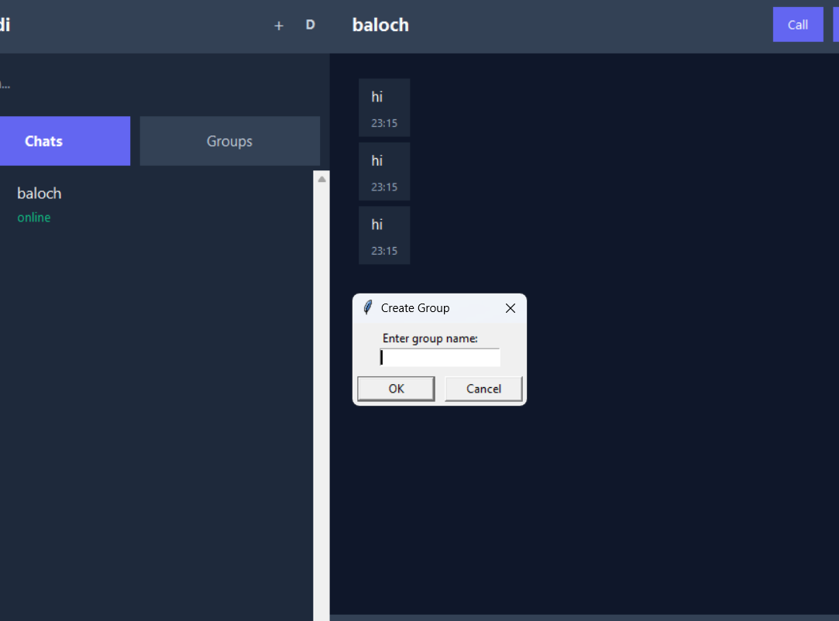
Image 3:- Group Joining
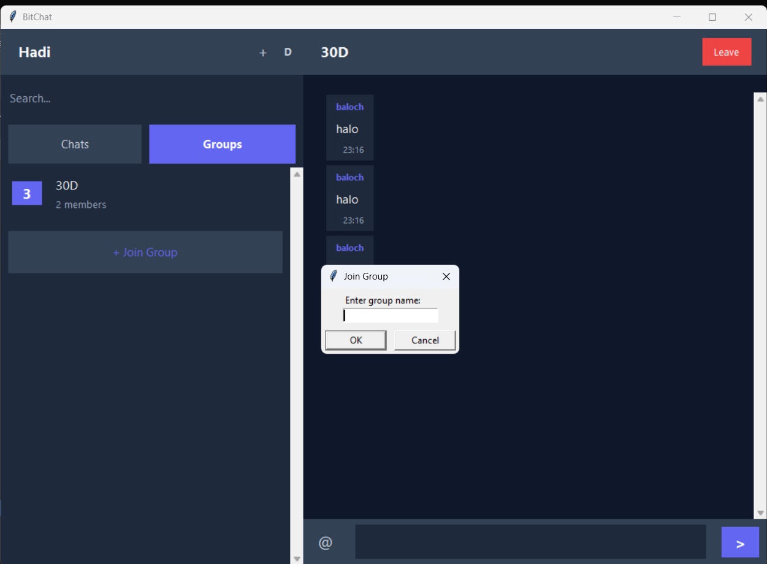
Image 4:- Live Message Notification
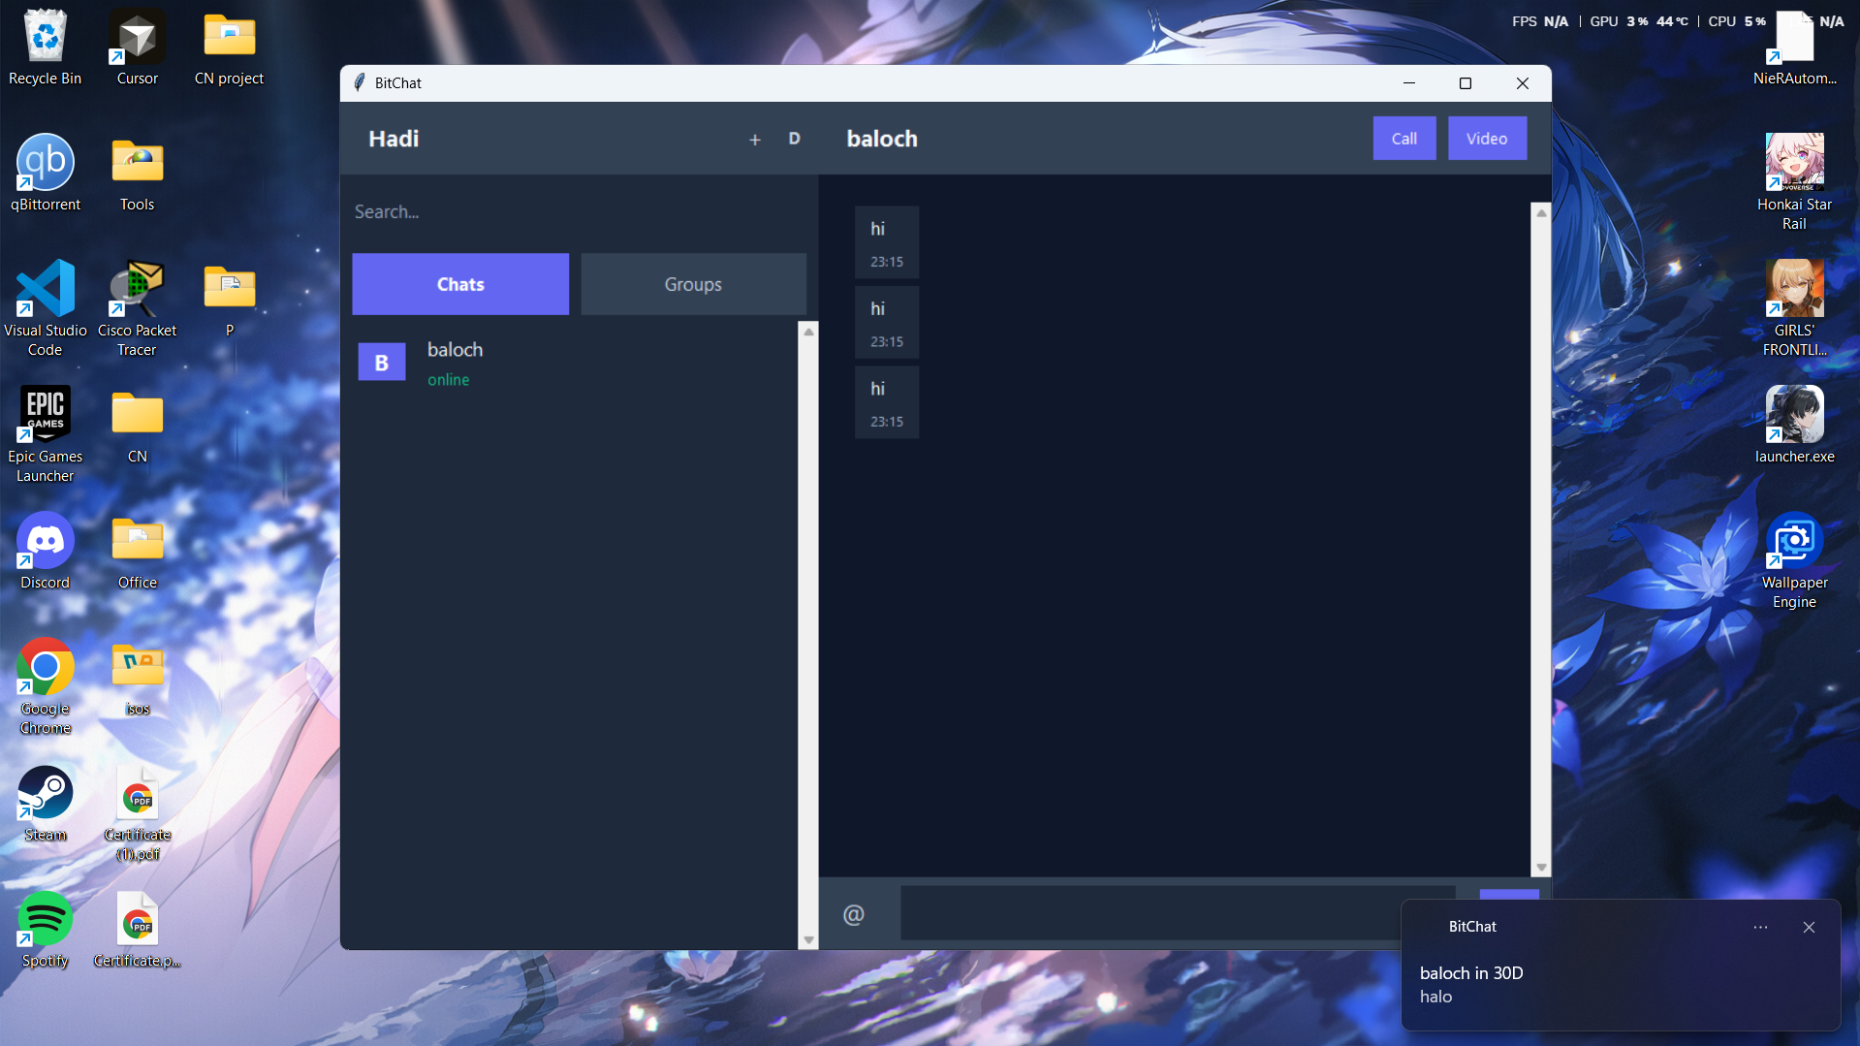
Image 5:- Image Sending
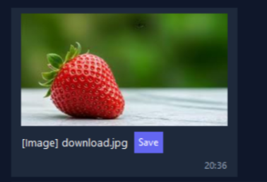
Image 6:- Unread Message Count

Image 7:- Video call
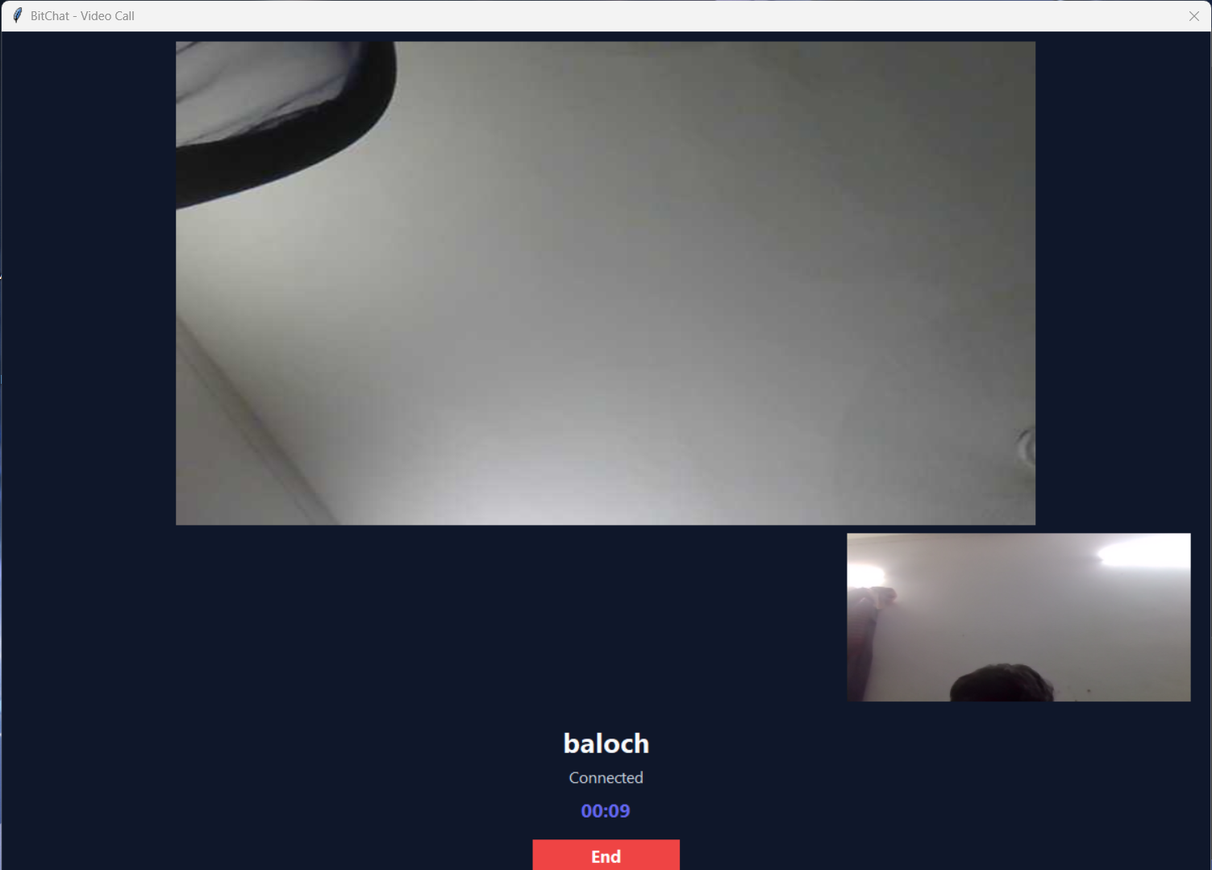
Image 8:- Voice call
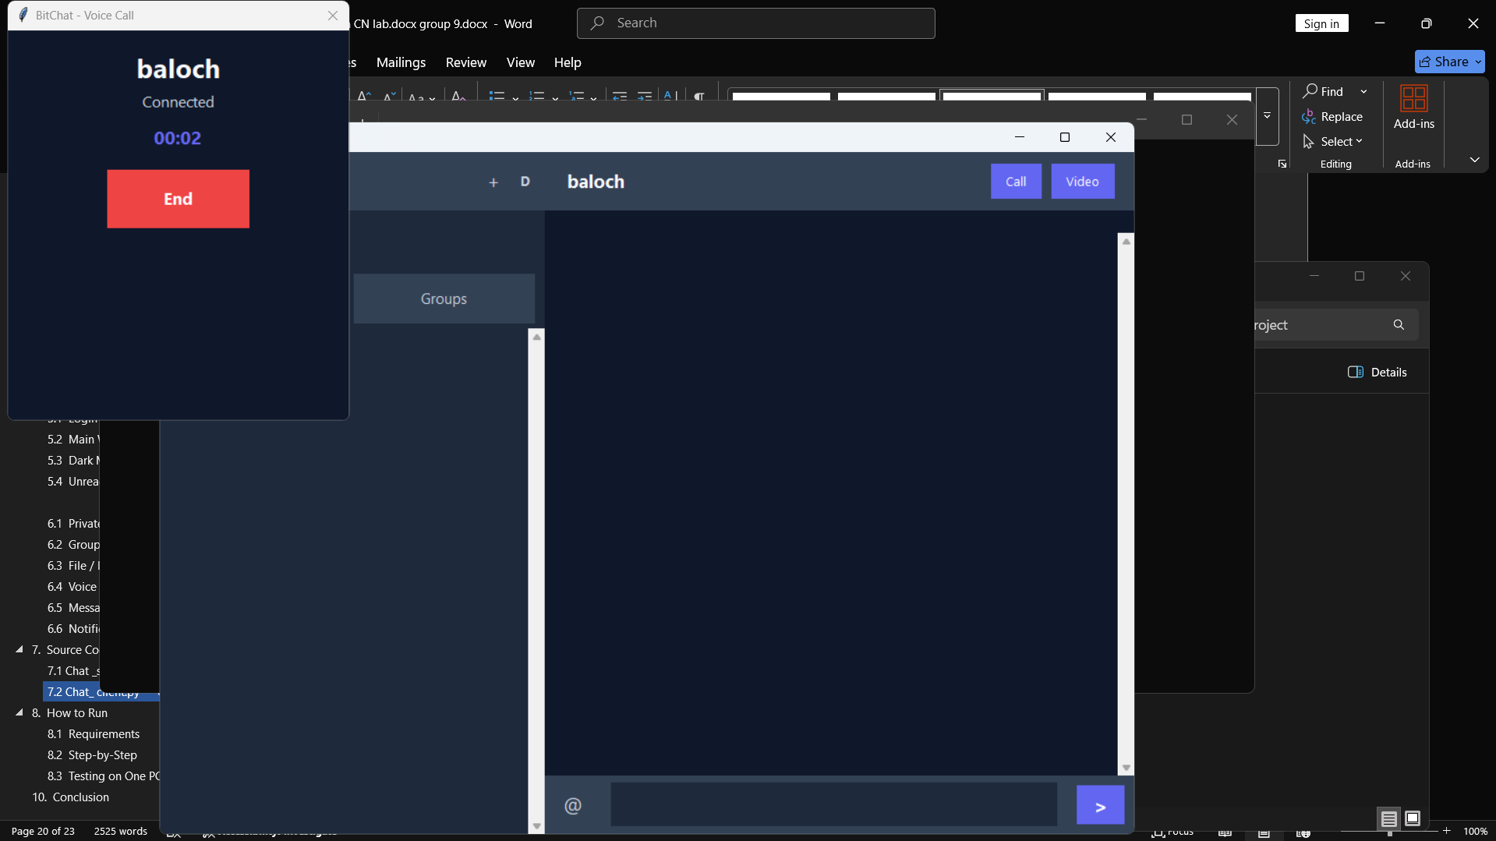
Image 9:- Video Sending
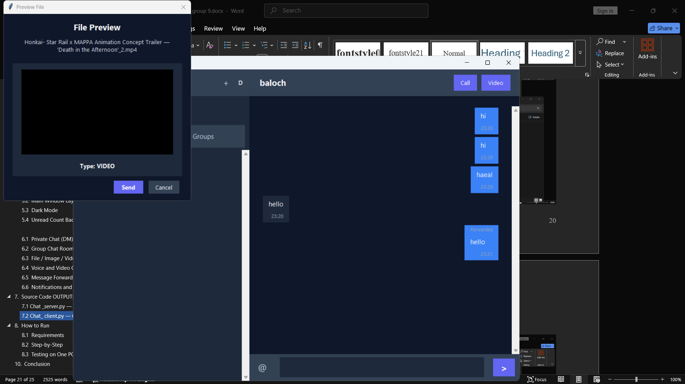
Image 10:- Forward message option
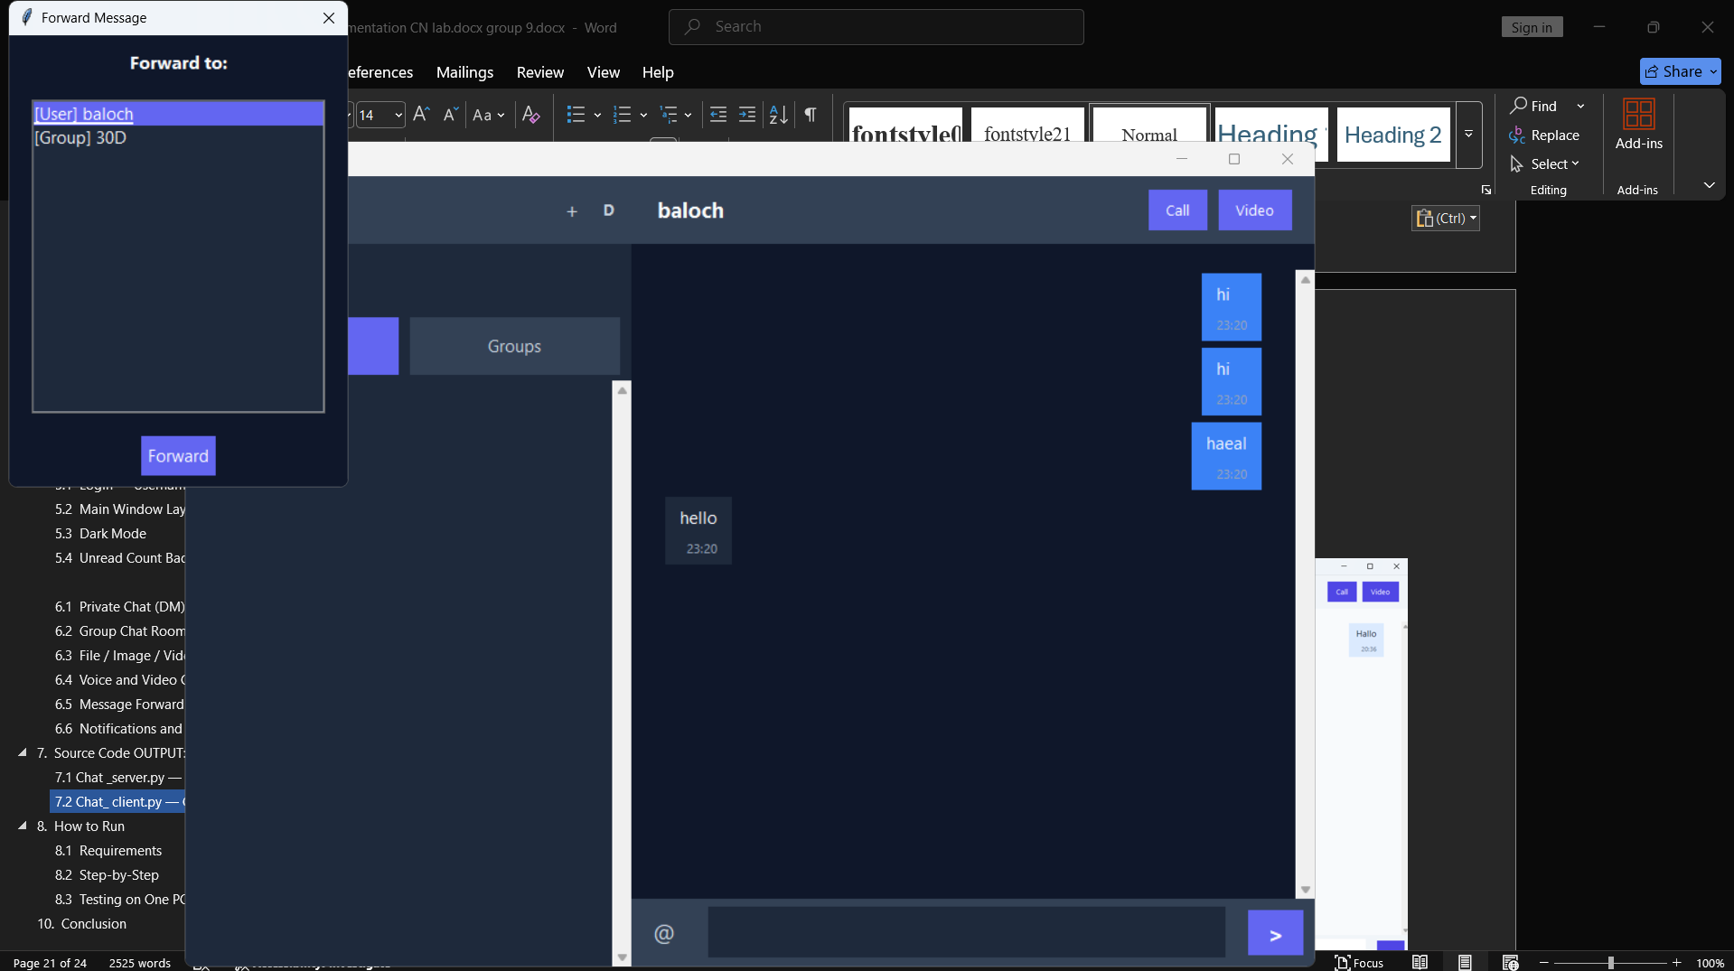
Image 11:- Forward message view
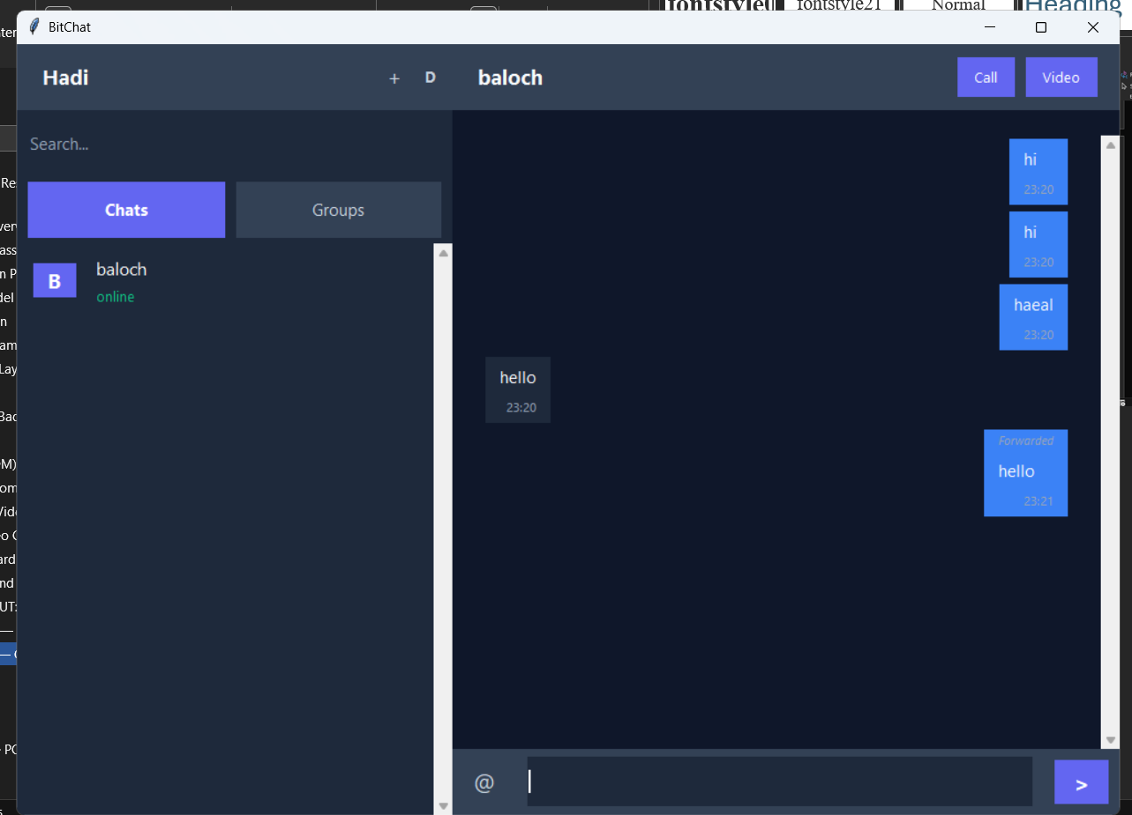
Image 12:- Full App view Light Mode
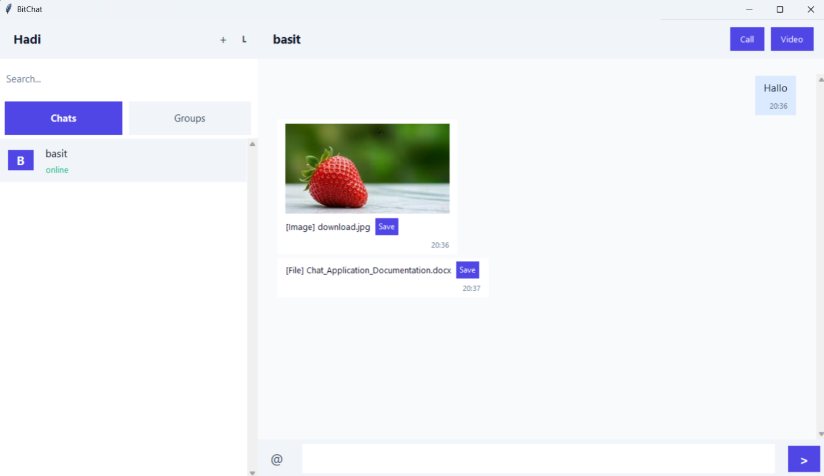
Image 13:- Full App view Dark Mode
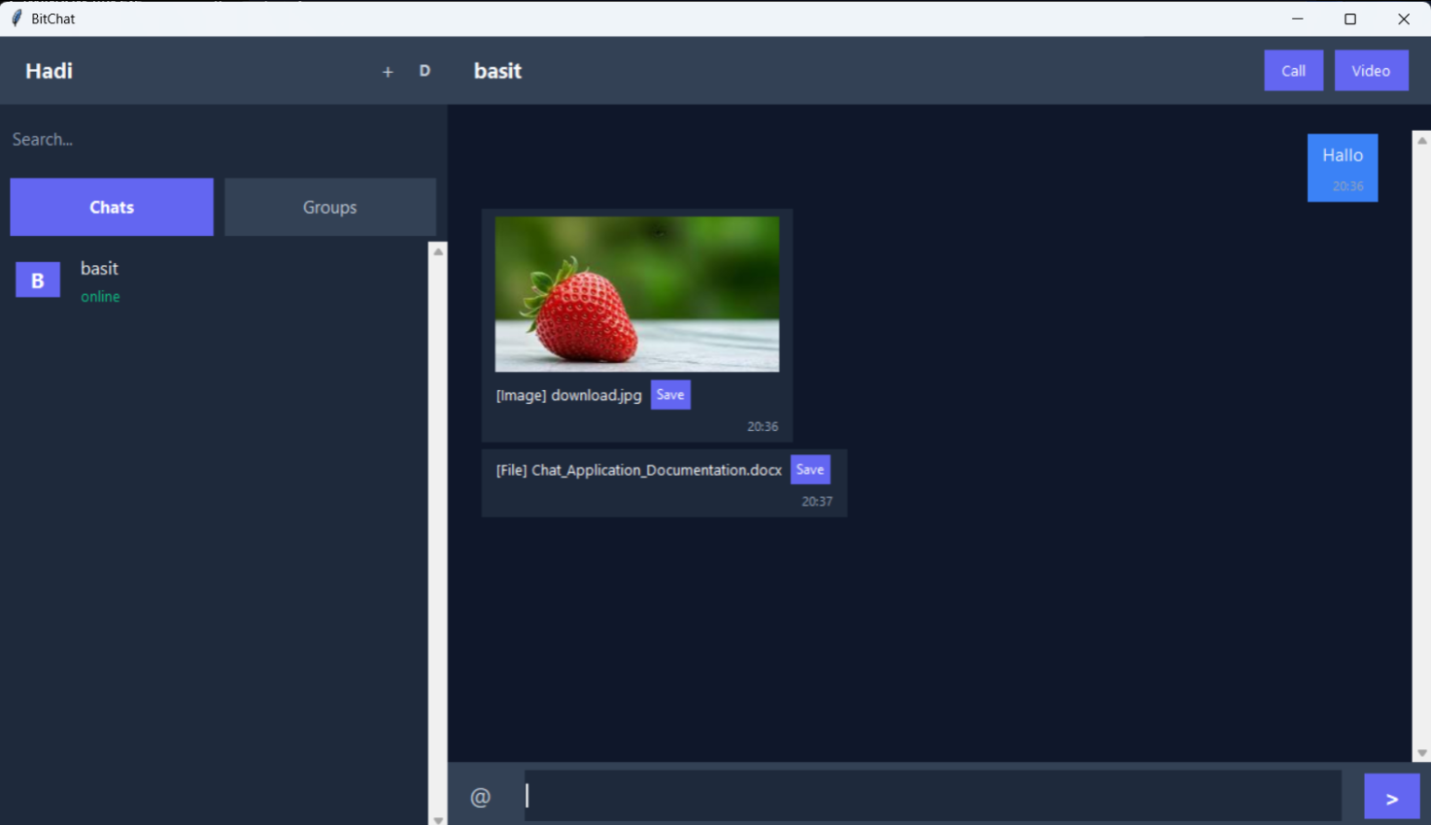

8. How to Run

8.1 Requirements
- Python 3.9 or higher
- pip install opencv-python pyaudio Pillow plyer playsound
- All clients must be on the same LAN (or use 127.0.0.1 for same PC testing)

8.2 Step-by-Step
- Edit HOST in both server.py and client.py to the server machine's LAN IP (e.g. 10.75.26.30)
- Open a terminal → python server.py — server starts listening on port 55555
- Open a second terminal → python client.py — login dialog appears
- Enter a username and click OK
- Open more terminals and repeat Step 3 with different usernames
- Double-click a user for DM, use Create/Join for rooms

8.3 Testing on One PC
Run server.py once, then launch two or more client.py instances. Use 127.0.0.1 as HOST. For voice/video calls between two instances, the port mapping in the code differentiates the two clients (55556/55557 vs 55558/55559).

9. Testing and Results
The application was tested with three simultaneous client instances on a LAN. All features were verified successfully:
- Three clients connected simultaneously — all appeared in each other's sidebar
- Private DM — messages only delivered to the correct recipient
- Group rooms — created, joined, messages broadcast to all members, history replayed on join
- File transfer — PNG image sent in DM and in group room, saved correctly
- Voice call — request, accept dialog, call timer, hang up all functional
- Message forwarding — right-click forward appeared correctly with attribution
- Desktop notification — plyer alert appeared for off-screen DM
- Unread count badge — incremented and reset correctly on channel switch
- Dark mode — all UI elements switched correctly
- Disconnect — server cleaned up, other clients notified

10. Conclusion
This project successfully implements all nine specified features of a real-time multi-user chat application using Python socket programming. The modular two-file architecture (server.py + client.py) is clean, scalable, and well-documented. The use of length-prefixed JSON framing ensures reliable delivery of both text and binary data. Threading enables concurrent handling of multiple clients without any blocking.
The application demonstrates practical mastery of Computer Networks concepts: TCP/IP socket programming, client-server architecture, concurrent threading, binary data encoding with Base64, and real-time multimedia streaming with OpenCV and PyAudio. The result is a fully functional, production-quality chat system comparable in feature set to modern messaging applications.

